Day -5 Permissions:
- Users Groups Others
U g o
- Read
- Write
- Execute
- Providing others write, execute access
- 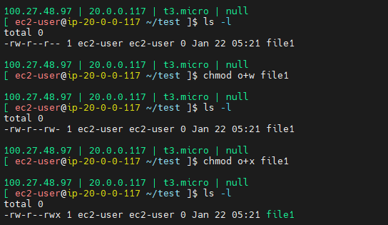
- Removing others write & execute access
- 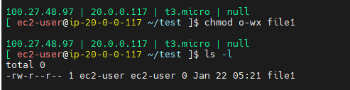
- 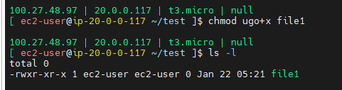
- Either owner of the file or root user can only change access levels
- R -> 4
- W -> 2
- X -> 1
- Only execute access to all users
- Chmod 111 file1
- 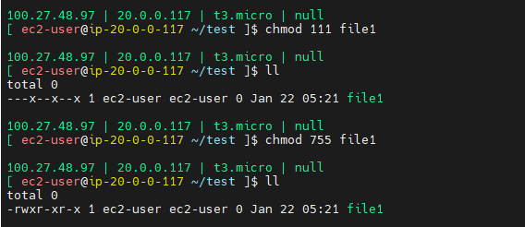

OWNERSHIP:
- Chown >user>:<group>
- Ownership can only be changed by root user. Not even owner pf the file/directory

- Lets assume you created a directory with sudo. Then directory will create with root owner. Now I want to change the directory and inside files to ec2-user & ec-user group

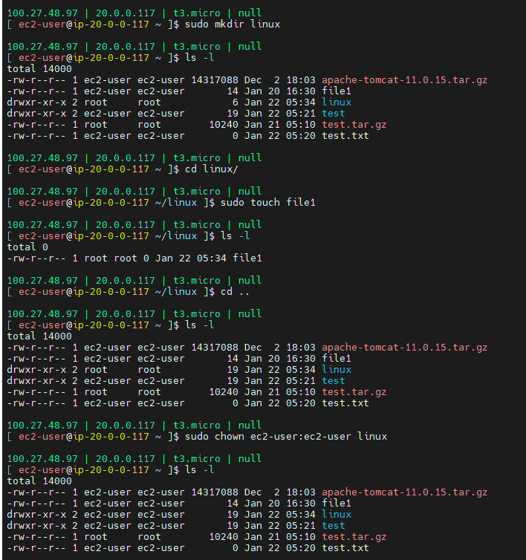
But still inside file is under root owner. Then -R (Recursive) to effect all inside files of the directory as well.
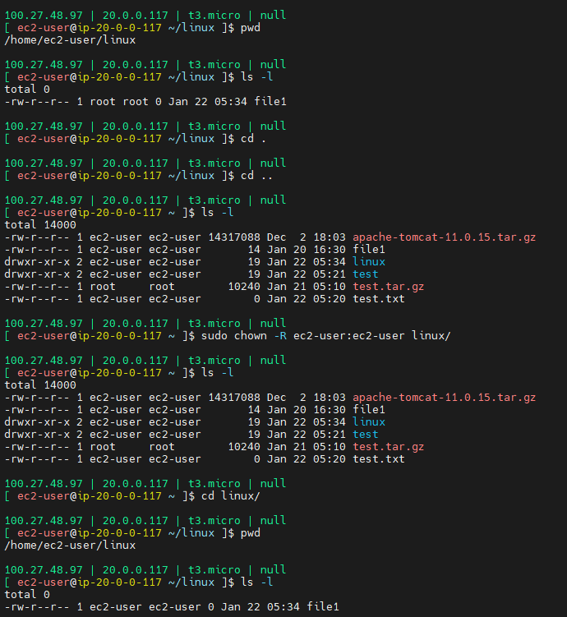

- Key based authentication
- Employee joins Oraganization
  - New user should generate keys (using ssh-keygen)
  - Send the public key to admin
  - Admin created .ssh folder inside user home directory
  - Permission should be 700 for .ssh
  - Ownership should be user including group
  - Create authorized_keys inside .ssh folder and paste public key in it.
  - Authorized_keys permission should be max 600
- Now lets practice with screenshots:
- Generate the keys ( ssh-keygen -f <username> )
- 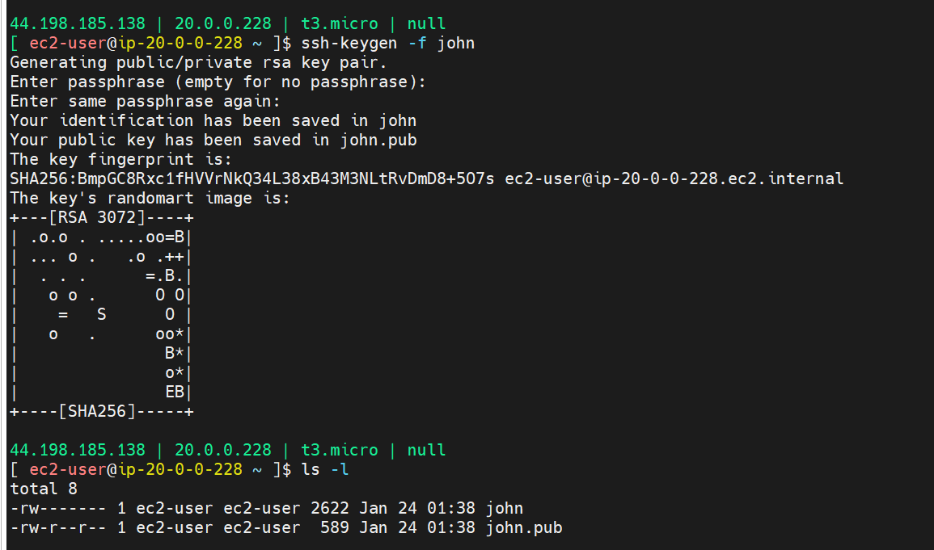
- Now keys are generated.
- Send the public key to admin to provide the access to the server. (need to share only public key “john.pub” and private key “john” should be very secure.)
- Let’s see how admin will provide access to “John”.
- First he will create a user in the server. Once useri s created then automatically home directory will be created for new user “/home/john”
- 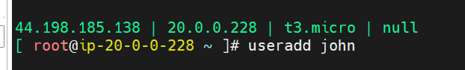
- Go to john home directory
- 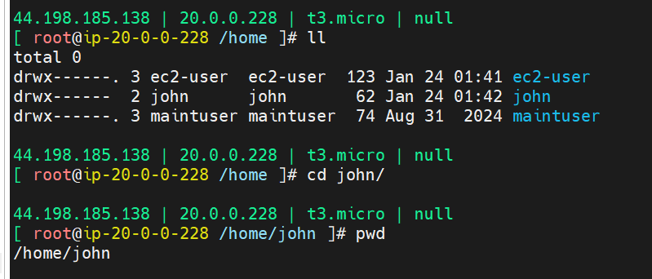
- Enter into “.ssh directory”
- And Create a file called “authorized_keys” (filename should be same)
- 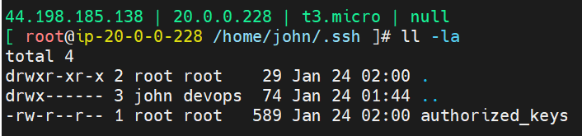
- Paste the public key inside the file.
- Change the ownership to user for .ssh directory
- 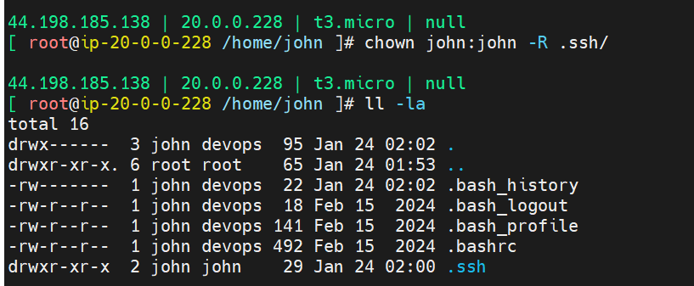
- Change the permission of .ssh to user only
- 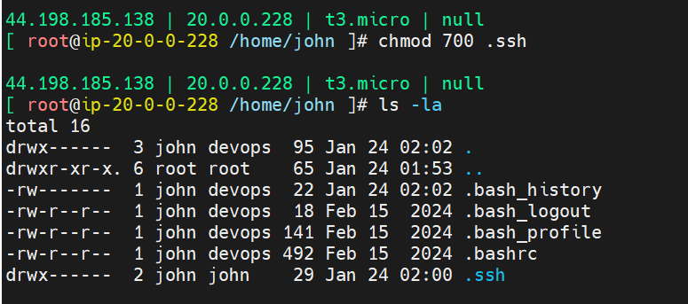
- Assign sudo permissons to John

- 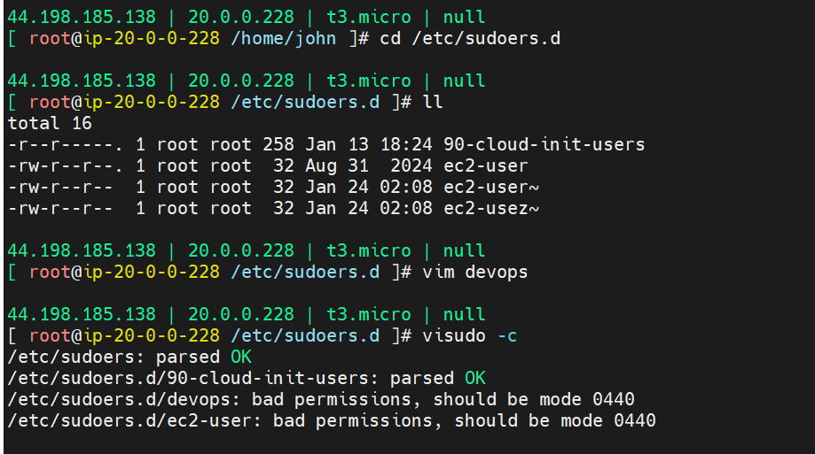
- 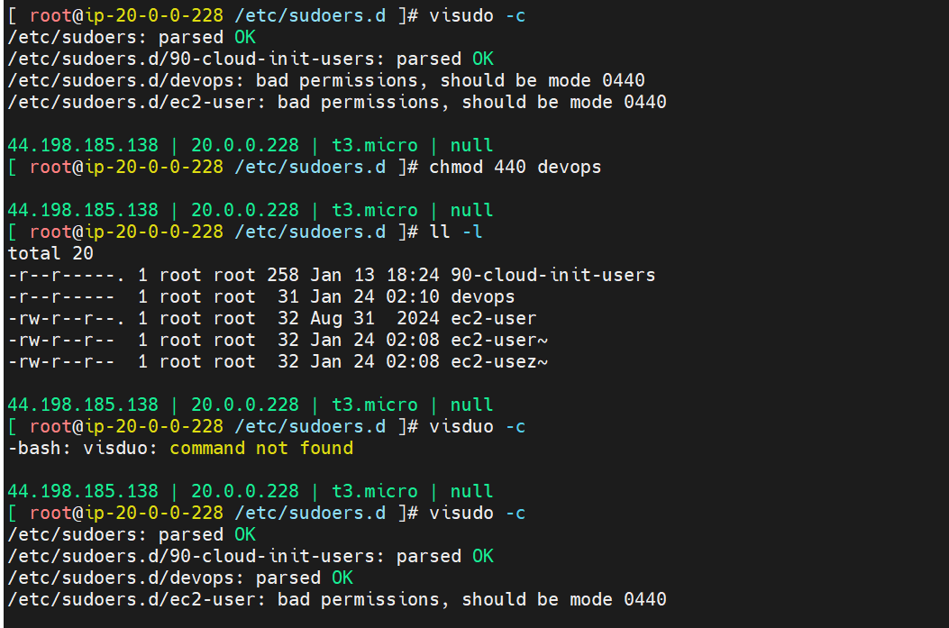

- Package Management:
  - $dnf list installed
  - $dnf search python
- Service management
  - $systemctl status <Service-name>
  - $systemctl start
  - $
- Network management
  - Netstat -lntp

